**eInvoicing Service Provid​er Accreditation Portal**

User Guide

**Table of Contents**

**1.** **Introduction** 3

**2.** **The Purpose of Creating the User Guide** 4

**3.** **Manual Review and Development** 5

**4.** **eInvoicing Service Provider Accreditation Portal Introduction** 6

**5.** **eInvoicing Service Provider Accreditation Portal** 7

**Logging in to the portal** 7

**The structure of the portal** 8

**Home** 9

**Submit Accreditation Application** 11

**My Application Status** 11

**Application Status codes** 13

**View Application** 14

**See emails** 15

**Actions** 17

**5. User Guide Version Control** 25

# **Introduction**

This manual provides detailed instructions on how to use the eInvoicing Service Provider Accreditation Portal and walks you through the portal’s functionalities.

Read this guide thoroughly before you submit your eInvoicing Service Provider Accreditation Application to get your work done faster and more efficiently.

# **The Purpose of Creating the User Guide**

The purpose of this document is to help Service Providers use the eInvoicing Service Provider Accreditation Portal.

Service Providers are encouraged to use this manual whenever they are trying to perform any activity on the eInvoicing Service Provider Accreditation Portal to make sure it’s done in a correct and efficient manner.

# **Manual Review and Development**

This User Guide will be reviewed by the Ministry of Finance and updated according to changes or updates.

# **eInvoicing Service Provider Accreditation Portal Introduction**

The below process flow diagram provides you a high-level overview of the Accreditation process:

Please make sure you enter accurate information while submitting your accreditation application. Entering wrong or inaccurate information might negatively affect the approval of your accreditation application. The information in your application on this portal is the sole responsibility of the Service Provider.

In case you face any problem with logging into your account, please contact us for assistance via the Ministry of Finance call center at 800533336 or email: [info@mof.gov.ae](mailto:info@mof.gov.ae)

# **eInvoicing Service Provider Accreditation Portal**

## **Logging in to the portal**

Accessing the portal requires logging in with UAE Pass. If you do not have an existing UAE Pass account, please visit <https://uaepass.ae/> to create a new account first.

You will be re-directed to UAE Pass login page to enter your credentials. Complete the Authentication process using UAE Pass mobile app

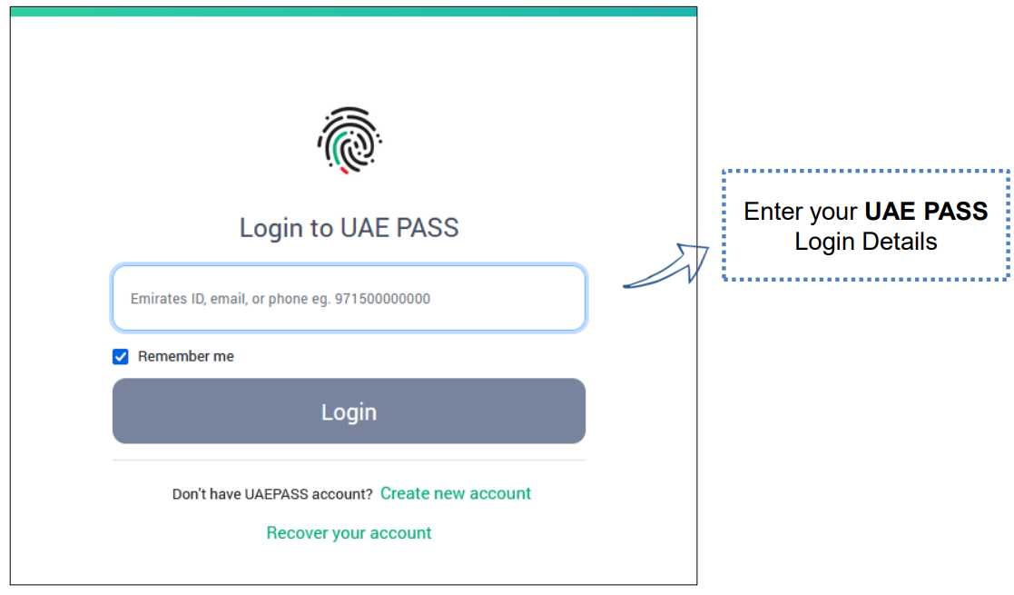

Once you are successfully authenticated, you will be redirected to the Home page of the eInvoicing Service Provider Accreditation Portal which is explained later in this document.

## **The structure of the portal**

The Portal **header** is always accessible both on the portal and in the accreditation application. The header allows you to:

* **Go to the “Home” page of the portal by clicking the Home icon**
* **Redirect to the Ministry of Finance website by clicking the Ministry of Finance logo**
* **Change preferred language (English vs. Arabic)**
* **Log out**

The **footer** of the portal provides:

* **Link to the portal user guide**
* **Link to FAQs**
* **The contact information of the Ministry of Finance**

The portal has **three main pages/tabs:**

1. **Home**
2. **Submit Accreditation Application**
3. **My Application Status**

## **Home**

The first time you log into the eInvoicing Service Provider Accreditation Portal, you will be shown the Home page. In this page you are provided with an introduction to the accreditation process. Here you can see:

* **The high-level flow diagram of the accreditation process**
* **Links to the user guide and FAQs**
* **Mandatory documents required for the accreditation application process**

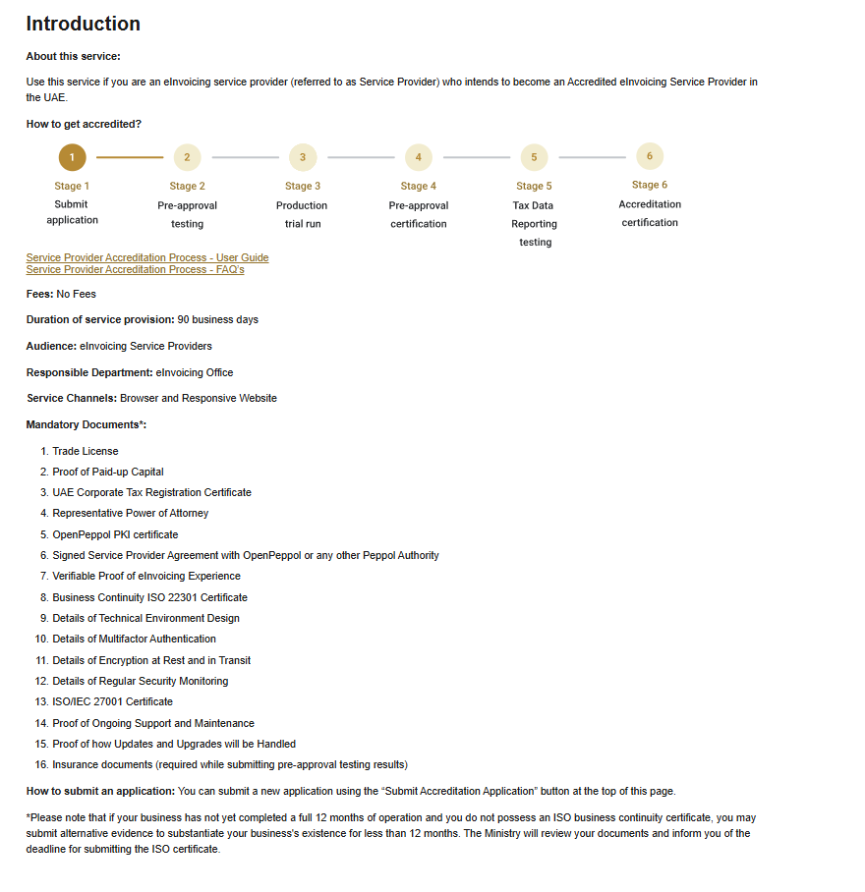

## **Submit Accreditation Application**

To start an accreditation application, click the ‘**Submit Accreditation Application’** button. You will then be redirected to the accreditation application page.

**Note:** this button will be grayed out and not clickable if you have already submitted an application. If you have started an application but have not yet submitted it, clicking this button will take you to your application draft.

## **My Application Status**

The 'My Application Status' tab will be empty during your first login as no application has been submitted yet.

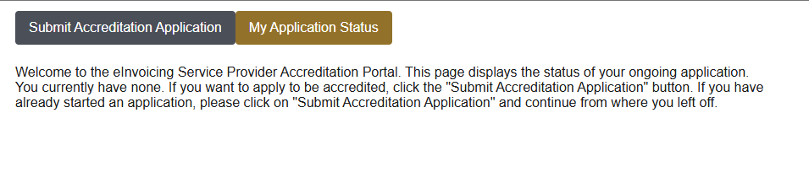

However, once an application has been submitted the application will be displayed in a table with the relevant information.

The table contains the following columns:

* **Application Number:** The application number, and two buttons: View Application and See emails. These buttons are explained in further detail in the subsequent sections of this user guide.
* **Submission Date:** The date and time when the application was submitted
* **Application Type:** The type of application (e.g. Accreditation application) + the Legal Name of the Service Provider
* **Status:** The status of the application will be automatically updated based on which stage of the accreditation process you are currently at. The different status codes can be seen in the next section.
* **Actions:** Thepotential actions that need to be taken by the service provider (e.g. respond to additional information required or uploading test results) and the related deadline. If no actions are needed, this column displays the text “*There are currently no actions needed*”. The different actions are described in a later section.

### **Application Status codes**

* **Under eInvoicing Office review:** The eInvoicing Office is currently reviewing your application, and no actions are needed from you currently.
* **Awaiting Service Provider response:** The eInvoicing Office is awaiting your response on a certain action (e.g. missing information or uploading of test results).
* **Service Provider response received:** The eInvoicing Office have received your response from a certain action (e.g. missing information or uploading of test results).
* **Service Provider pre-approved:** The eInvoicing Office have granted you the pre-approval accreditation with a certificate.
* **Service Provider accredited:** The eInvoicing Office have granted you full accreditation with a certificate and the application will now be closed.
* **Application rejected:** The eInvoicing Office have rejected your accreditation application and the application will now be closed.

### **View Application**

To view your submitted application at any time, click the ‘View Application’-button . This allows you to view and download a copy of your application in PDF format.

### **See emails**

Clicking on the ‘See emails’ button takes you to an overview of correspondences. Here you can see all communications received and sent from the eInvoicing Service Provider Accreditation Portal, associated with your accreditation application.

Clicking on any link in the ‘Document Title’ column opens the email in PDF format. The email can be downloaded or printed.**

### **Actions**

During the accreditation process, various actions will require your response through the submission of specific information (visible in the Actions column). Some of these actions are mandatory, while others occur only under specific circumstances.

When clicking the button Respond in the action column you are redirected to the required page with options to enter the required information, attach any required documents and submit them.

Some examples of these actions are explained below

#### **Additional Information Required**

This action appears if the eInvoicing Office determines whether any documentation within the application is non-compliant or incomplete. Issues may range from incorrect contact details to insufficient supporting documentation.

Click the “next” button to enter the additional information or amendments that have been requested and then click on “Submit”

#### **ISO 22301 Certificate**

If you selected "No" in response to the question, "*Do you have the Business Continuity ISO 22301 Certificate?*" on your application, you will be required to upload the certification upon acquisition, within the specified deadline.

#### **Insurance documents**

Once the eInvoicing Office has reviewed your initial application, you will be required to upload the necessary insurance documents.

#### **Pre-Approval OpenPeppol Testing**

Once the eInvoicing Office has assessed that you are ready to perform the Pre-Approval Testing with OpenPeppol, you will get an action to upload the documentation once testing is completed.

#### **Pre-Approval End-User Onboarding Testing**

Once the eInvoicing Office has assessed that you are ready to perform the Pre-Approval End-User Onboarding Testing with the FTA, you will get an action to upload the documentation once testing is completed.

#### **Production OpenPeppol Testing**

Once the eInvoicing Office has assessed that you are ready to perform the Production Testing with OpenPeppol, you will get an action to upload the documentation once testing is completed.

#### **Production End-User Onboarding Testing**

Once the eInvoicing Office has assessed that you are ready to perform the Production End-User Onboarding Testing with the FTA, you will get an action to upload the documentation once testing is completed.

# **5. User Guide Version Control**

|  |  |  |  |  |
| --- | --- | --- | --- | --- |
| **English Version** | **Date** | **Description of Changes** | **Editor** | **Approver** |
| 1.0 | 05-03-25 | Frist version | MoF Supplier Team | MoF |